2016

Next Generation Technologies and Services  
Project PROPOSAL

October 15, 2016

Contents

1. Student Identification 2

2. Proposed Theme 3

3. Project Scope 4

4. Scheme 5

5. Security concerns 6

6. List of equipment 7

7. Bibliography used (links) 8

## Student Identification

|  |  |
| --- | --- |
|  | Maciej Wagner, 2161573  Master's degree student in Computer Engineering – Mobile Computing  Hrvoje Nemcanin, 2161548  Master's degree student in Computer Engineering – Mobile Computing |

## Proposed Theme

|  |  |
| --- | --- |
|  | Goal of project is to create innovative product with Raspberry microcontroller which can help people to check their health conditions from time to time or in extreme situations.  Purpose is receiving information of user’s heart rate which can indicate whether heart rate should be normal in some situations or is risen to the higher rate.  User can be given his heart rate at any time by touching the sensor who’s connected to raspberry pi controller.  User can also record his activities during the critical heart rate moments and store the information to the external data storage.  Since the goal of the course is to get information anywhere, anytime user have option to access its data on the web. |

## Project Scope

|  |  |
| --- | --- |
|  | In general, goal is to write stable software for micro controller which can communicate with other components and its services.  Before that some steps need to be done, and those are next:   * **Prototype** - creating a prototype or scheme with all the components and how they communicate with other services. * **Coding** - create code for “python” scripts which make microcontroller and its components communicate with the web server. * **Web Service** – create a web service * **Backup -** create backup mechanism in which user can access its results anywhere, anytime.   When it comes to scope, scope refers to a purpose as it’s mentioned before is the health care of the user. |

## Scheme

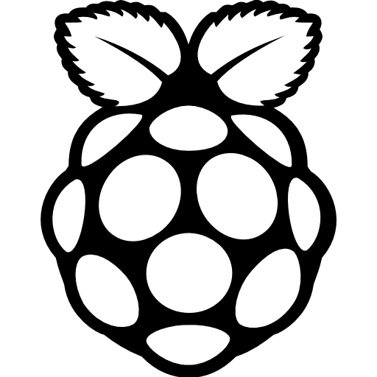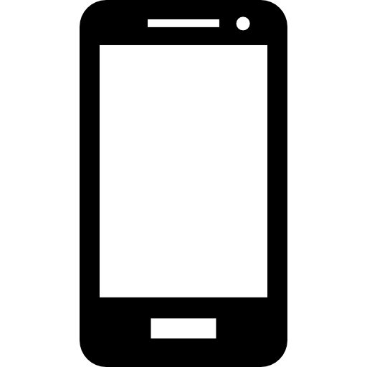

INTERNET

* Raspberry pi icon represents microcontroller with wired microphone and camera.
* Smartphone icon represents users’ smartphone
* Storage icon represents external hard drive, OneDrive, Google drive etc, for storing backup
* Human icon represents user

## Security concerns

* Sniffing communication between smartphone, and raspberry pi
* Someone can pretend that he is device owner, and connect with device web service
* Sniffing communication between storage and smartphone/device
* Creating fake access point, for the device/smartphone and start Man in the middle attack

## List of equipment

* Raspberry pi microcontroller
* Camera
* Microphone
* Pulse sensor

## Bibliography used (links)

|  |  |
| --- | --- |
|  | * <https://www.raspberrypi.org/about/> * <https://www.raspberrypi.org/downloads/> * <http://elinux.org/RPi_Distributions> * <https://www.raspberrypi.org/documentation/usage/python> |

|  |  |  |  |  |  |  |  |  |
| --- | --- | --- | --- | --- | --- | --- | --- | --- |
| Approved By |  |  | Date |  | Approved By |  |  | Date |